Name: Sergiy Palguyev
Username: spalguyev3
GTID# 903272028
Report
- The probability of winning $80 within 1000 sequential bets is 100%. As seen by the Figure 1, every episode will saturate to $80 well before the full 1000 bets are exhausted. This is true because we have an unlimited budget to work with.
- The expected value of our winnings after 1000 bets is around $71. This can be deduced from the Mean of 1000 simulations by taking their average.
- The standard deviation does stabilize and converges to the value of $0. This is due to the fact that our bank roll is unlimited and we end up winning $80 for every possible episode.
- To count probability, one can look at how many simulations reached $80 after 1000 bets and how many did not. This is done in code and results in a probability of 63.5% as 635/1000 runs resulted in an $80 win.
- The expected value of our winnings after 1000 sequential bets is approximately -$31. This can be deduced from the Mean of 1000 simulations by taking their average.
- The standard deviation does seem to stabilize and converge at the value of about $160. This can be attributed to the fact that our limited bank-roll which is always the maximum that we can lose.

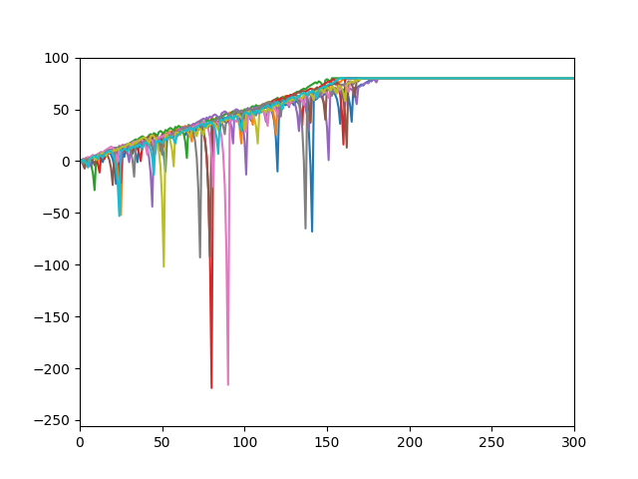
Figure 1: Experiment 1, winnings of 10 runs.
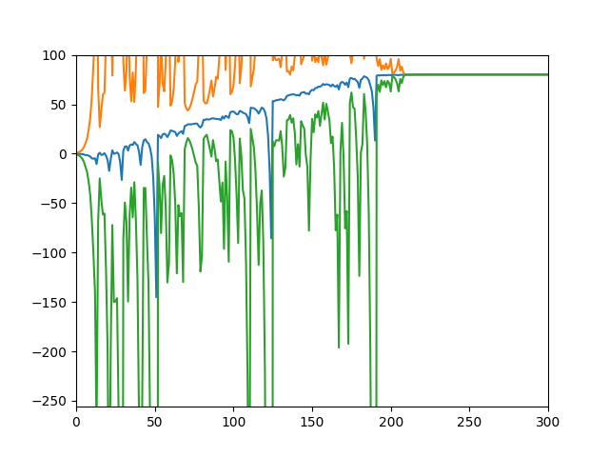
Figure 2: Experiment 1, mean of 1000 runs
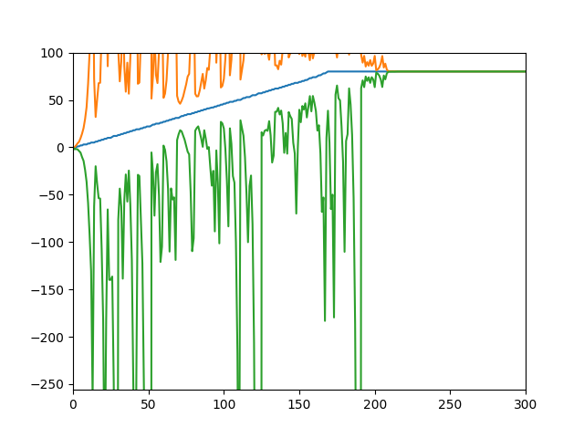
Figure 3: Experiment 3, median of 1000 runs
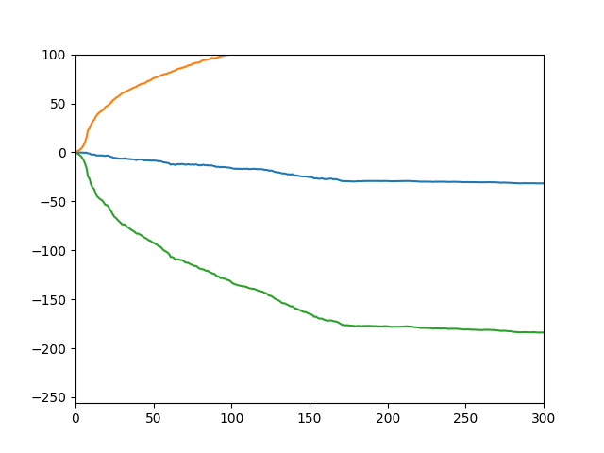
Figure 4: Experiment 2, mean of 1000 runs
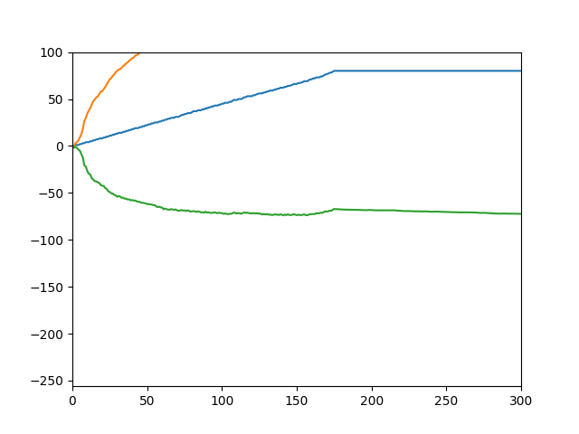
Figure 5: Experiment 2, median of 1000 runs

